# *Web Programming IV (420-C40-HR)*

# *Lab 1 – First ASP.NET*

Date assigned: Thursday, January 19, 2017

Date due: **Thursday, January 19, 2017, 4:00 p.m.**

**Learning Objectives**

Upon successful completion of this lab exercise, the student will be able to:

* Set up your calendar for Semester 4
* Understand how to create a simple ASP.NET website
* Understand how to create ASP.NET Web Pages

**Part A – Home Drive Set-Up 5 marks**

1. Go to your H drive and copy your files from the fall courses to another location such as Dropbox or a USB drive. This is an optional step; however, you have limited space on your H drive and will likely run out. You probably want a copy of the files from last term to refer to throughout this term, so I would copy them rather than delete them.
2. On your H drive create a separate folder for each of your computer science courses this term. Create four folders named: 420-B42, 420-C40, 420-D20 and 420-E21 respectively.
3. Inside each of these folders create two subfolders, one for Labs and one for Assignments.

**Part B - Microsoft® Outlook Set Up 2 marks**

1. You will usually access your college email using webmail. There is another way to access your College e-mail using Microsoft Outlook. Start Microsoft Outlook 2013 by selecting **Start, Programs, All Programs, Microsoft Office 2013, Outlook 2013**. The Outlook Startup window will open. Click Next.

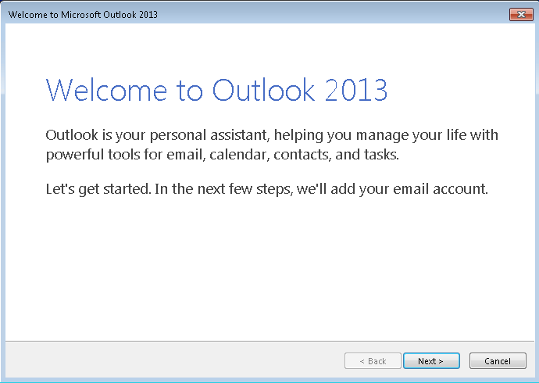

1. The next window asks you to confirm that you want to set up an account. Make sure the Yes option is highlighted and click Next.

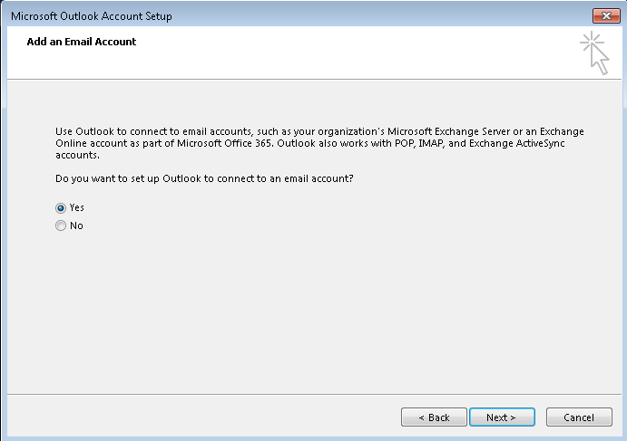

1. The Add New Email Account screen is displayed. Your name and email address should be filled in by default. If your name is not automatically filled in, add your email address in the Email address field. Your email address is your username with @cegep-heritage.qc.ca added to it.

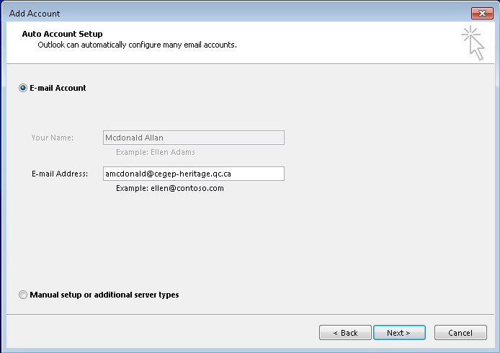

1. Click **Next**. Your email account should be successfully set up now:

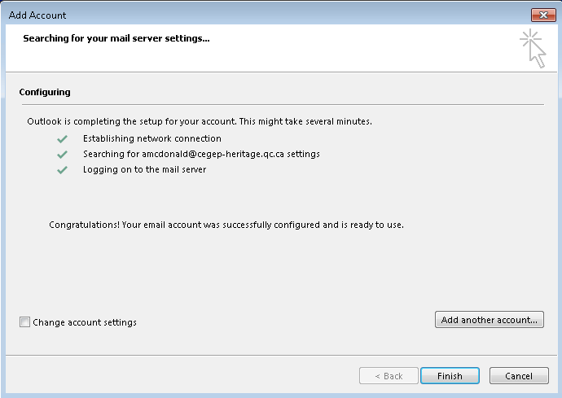

**If you do NOT receive the above screen, let me know immediately. Do NOT click finish. We may have to set up your account manually.**

1. Click **Finish**. Outlook 2013 will now open.

***Note***: You have set up your profile on the desktop computer. The next time you use this computer, simply open Outlook and your profile will be selected.   
  
If you use another computer, you will have to repeat this procedure to set up your profile there.

1. You should have a message (perhaps 2) from Ron inviting you to a pizza lunch on February 5. Please accept or decline the invitation and make sure you send Ron a message as you do.

**Part C - Calendar Set Up**

|  |  |
| --- | --- |
| Step | Marks |
| 1. In Outlook, select **Calendar** from the bottom Task Bar and change the view to be **Week**. |  |
| 1. Set up your timetable by repeating the following steps for each course block in your timetable.    1. Starting with today, Thursday, January 19, select a block of time that corresponds to the course, right-click, and then select **New Recurring Appointment** on the shortcut menu.    2. Ensure that the Appointment Recurrence is set up as follows:       1. The Start and End time should be the starting hour and ending hour for the block in your timetable. The end time should not be changed to be 10 minutes before the hour. The Duration is automatically calculated.       2. The Recurrence pattern should be weekly, and the appropriate day should be checked.       3. Set the **Range of recurrence** to **End by: April 21, 2016**. Click **OK**.    3. In the **Subject** box, type the name of the course.    4. In the **Location** box, enter the room number.    5. In the top ribbon bar, set the Reminder for the entry to be None.    6. Colour-code your courses using categories. Each course must have its own colour. | **/15** |
| 1. Open the PDF file “Academic Calendar 2016-2017” in Moodle. |  |
| 1. Change your Outlook calendar to match the academic calendar as follows:    1. Delete the occurrences for the week of February 27- March 3 for Reading week.    2. Delete the occurrences on Friday, April 14 for Good Friday.    3. Delete the occurrences on Thursday, April 20 and move all courses from Monday, April 17 to Thursday, April 20. | **/5** |
| 1. While viewing your calendar click on the Share My Calendar link on the left side.   Share your calendar with the user **#Teaching Staff Computer Sciences** (all the Computer Science teachers). | **/3** |

**Part D – Single Page Application**

1. Start Visual Studio and create a new Web site (File=>New=>Web Site) using the C# Templates. Make it an ASP .NET Empty Web Site. The site must be in the folder C40L01 which is a subfolder of H:\420-C40\Labs\.

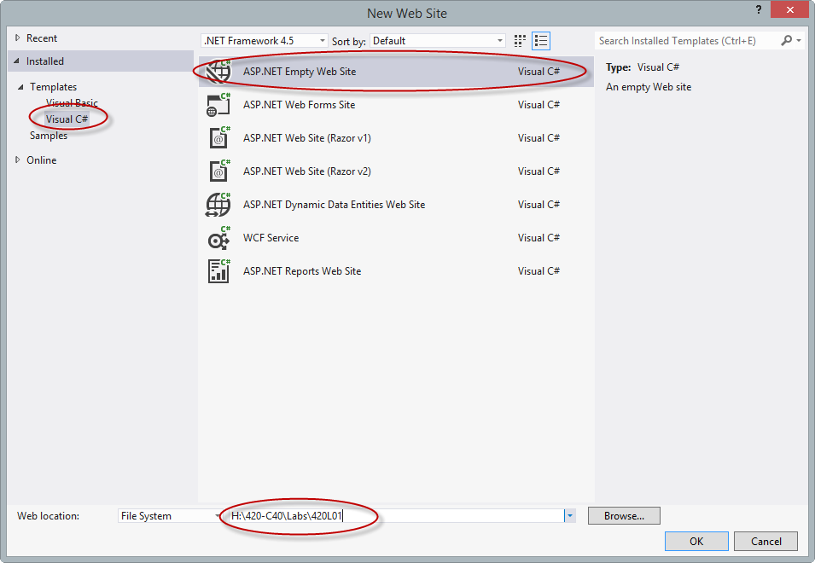

1. Add a folder named images to the project (right-click on the name of the Solution and choose Add=>New Folder) and add the Heritage logo to it (Select the folder, right-click, choose Add=>Existing Item…, browse to the file and select it). You can find the file for this logo on the S drive for the course (VS will copy the file from this location to your images folder)
2. Create a new Web Form by right-clicking on the project in the Solution Explorer and choosing Add New Item. Choose to Add a Web Form. Call the new item Default.aspx (this should be the default value).

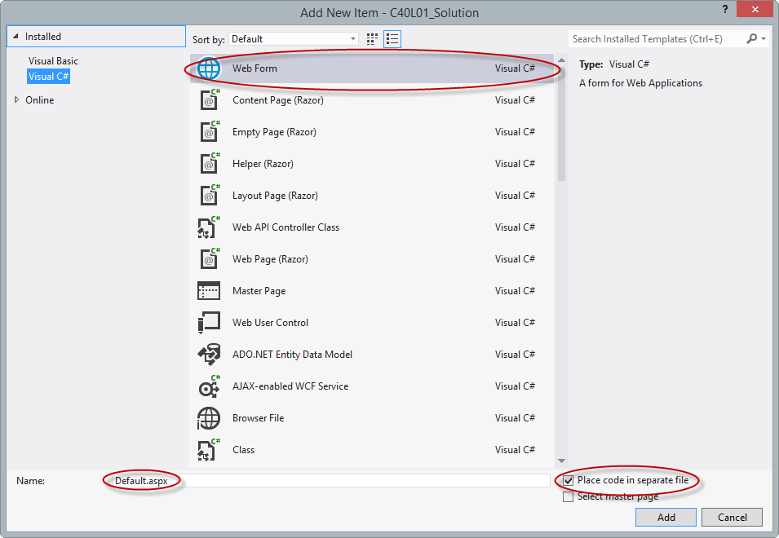

1. Switch to Design mode and drag the image of the Computer Science logo to the div inside the form. You will be prompted to enter the Alternate Text for the logo.
2. Next to the logo add the words My First ASP Page and format it as a header level 1 (use the drop down in the list)

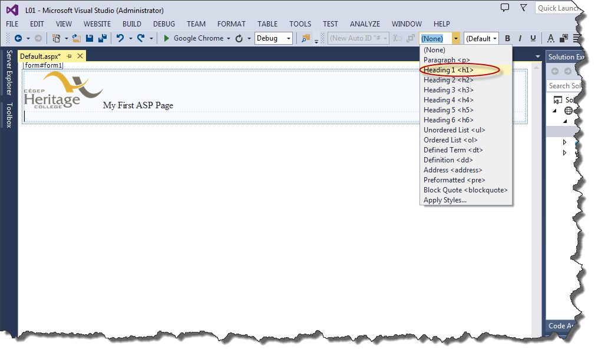

1. Go to the next line (hit return) and add the text **Principal (P):**
2. On the same line, use the Toolbox and add a TextBox control (under Standard controls). Do not worry about naming or formatting the TextBox at this point we will do that in a bit.

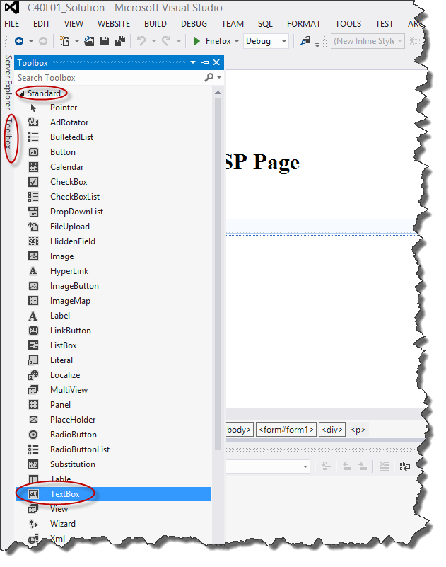

1. Repeat steps 6 and 7 to add the text **Rate (R):** and **Time (t):** with text boxes on the next two lines (actually they will be in two paragraphs).
2. After the three input lines add the text **Total:**
3. On the same line, use the Toolbox to add a Label
4. On the next line, use the Toolbox to add a Button
5. At this point your page should look like this:

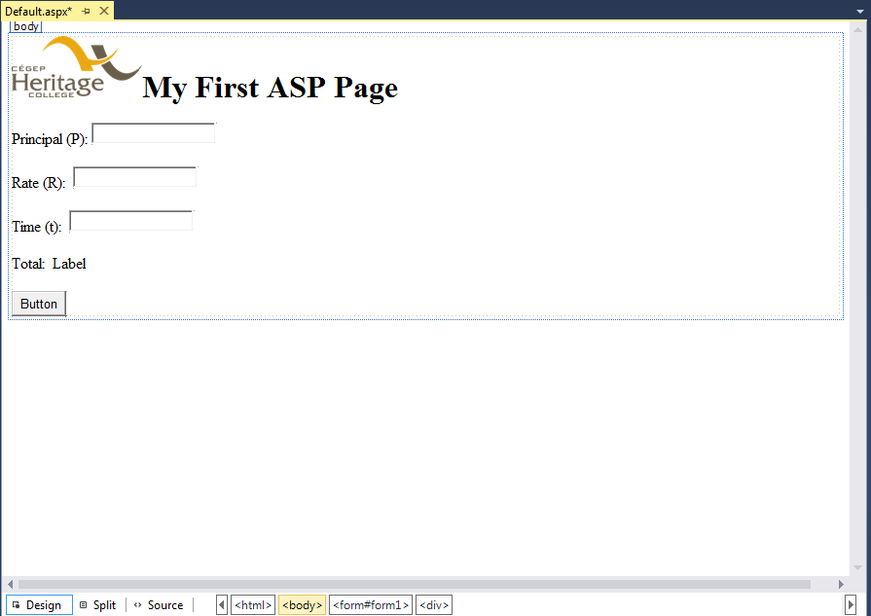

1. Now we will format the text boxes. Select the first textbox. Notice that in the bottom right-hand side of the Visual Studio window there is a box labeled Properties. This contains the properties of the selected control. We have a standard naming convention for all controls (you can find it on the Moodle page under Resources). For TextBoxes the name of the control must start with txt. With the first TextBox selected, slide to the bottom of the properties window and change the name of the text box to txtPrincipal. Just above that there is a Width property which you should change to 4em (the em is required).

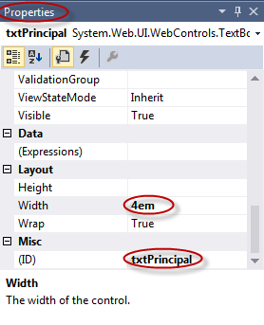

1. Do the same for the other two text boxes changing the ID to txtRate and txtTime respectively and giving both a width of 3em.
2. Select the label and change the properties for the Text to “Calculation goes here” and the ID to be lblTotal.
3. Select the button and change the properties of the Text to be Calculate and the ID to be btnCalc.
4. At this point the page looks like this:

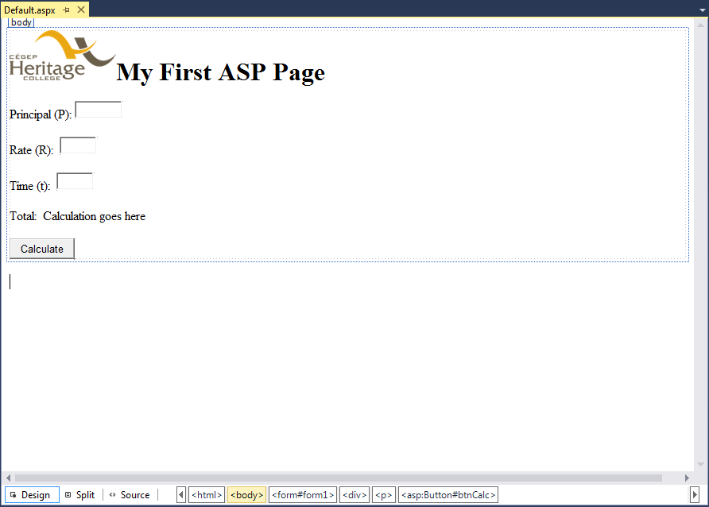

1. Double click on the button. The “Code Behind” page will open and a method called btnCalc_Click will be created. Add the following code:

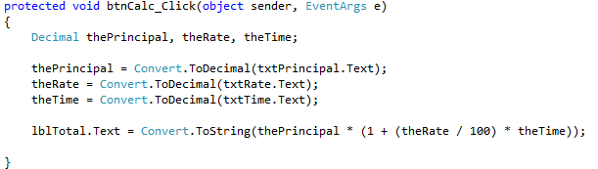

1. Run and test the application under a number of conditions. Change some properties and test it some more.
   1. P = 10000, R = 3.875, t=5…total should be 11937.50000
   2. P = 100, R = 5, t=1…total should be 105.00
   3. P=500, R=2, t=10…total should be 600.00
2. Format the result as currency by adding a new decimal variable called theTotal and performing the calculation and assigning the result to this variable. Then change the lblTotal line to:   
   

Yes I know you can do it in one line, but I want to see the interim value.

1. Re-test to make sure that the value comes out as currency (for example, the result from test a should be $11,937.50.
2. Look at the source code of the aspx page. You will see some very common HTML code and some odd tags that start with asp:. You will also see some embedded CSS in the <head> section (probably a class called auto-style1). Create an external stylesheet called default.css in a folder called styles. Copy the embedded style to the external style sheet and rename it so that it is appropriate (remember you will also have to rename where it is used in the page). Add some CSS in the external stylesheet to format the page.

**To submit**

When you have completed the lab exercise, show me the results and then create a single zip file called YourUserName_C40_L01.zip. Copy the file to the Moodle page for the course.